SIMATS ENGINEERING
ASSESSMENT TOOL 2

COURSE NAME: OBJECT ORIENTED ANALYSIS AND DESIGN
COURSE CODE: CSA1102

COURSE OUTCOME COVERED

CO2: Design UML diagrams to represent system requirements and architecture. (BL3)

Assessment Tool Weightage: 60%

Course Faculty: Dr R Dhanalakshmi

QUESTIONS: 6 Total Marks:60

Annexure A

Application Based Questions

Code of Conduct:

I ______192421397______________ (Name / Reg No) certify that this submission is my original work and that I have adhered to the guidelines specified for this assessment.
I understand that any violation of academic integrity rules will result in disciplinary action.

Signature of the student:b.amar

1. Use Case Diagram Analysis (10 Marks)
Problem understanding. The Smart Pharmacy Management System lets customers search medicines, upload prescriptions, order and pay online, while pharmacists verify prescriptions and dispense medicines, and administrators manage inventory and user accounts. The existing design does not define who is responsible for what, so the requirements are analysed below to identify all actors, the missing use cases and the relationships between them.
Step 1 – Actors identified
Actor | Type | Responsibility
Customer | Primary | Registers, searches medicines, uploads prescriptions, places orders, pays online and tracks orders.
Pharmacist | Primary | Verifies / rejects prescriptions and dispenses medicines.
Administrator | Primary | Manages inventory, user accounts and reports.
User (abstract) | Generalised | Common parent of Customer, Pharmacist and Administrator; all of them log in.
Payment Gateway | Secondary (external) | Validates and processes online payments.

Step 2 – Use cases and missing use cases
The given requirements already mention search, upload prescription, place order, make payment, verify prescription, dispense medicine, manage inventory and manage user accounts. The following use cases were missing and are added to make the design complete: Register / Login, Authenticate User, View Medicine Details, Validate Payment, Track Order Status, Apply Discount / Coupon, Reject Prescription, Send Notification, Generate Low-Stock Alert and Generate Reports.
Step 3 – Relationships used
Relationship | Where applied | Reason
Generalization | Customer, Pharmacist, Administrator → User | Shared login behaviour is inherited from the abstract User actor.
«include» | Register/Login → Authenticate User; Search Medicine → View Medicine Details; Place Order → Make Online Payment; Make Online Payment → Validate Payment; Dispense Medicine → Verify Prescription; Dispense Medicine → Send Notification | The included behaviour is always executed as part of the base use case.
«extend» | Upload Prescription → Place Order; Apply Discount → Place Order; Reject Prescription → Verify Prescription; Generate Low-Stock Alert → Manage Inventory | Optional / conditional behaviour (e.g. only for prescription-only medicines or when stock is low).

Step 4 – Use Case Diagram
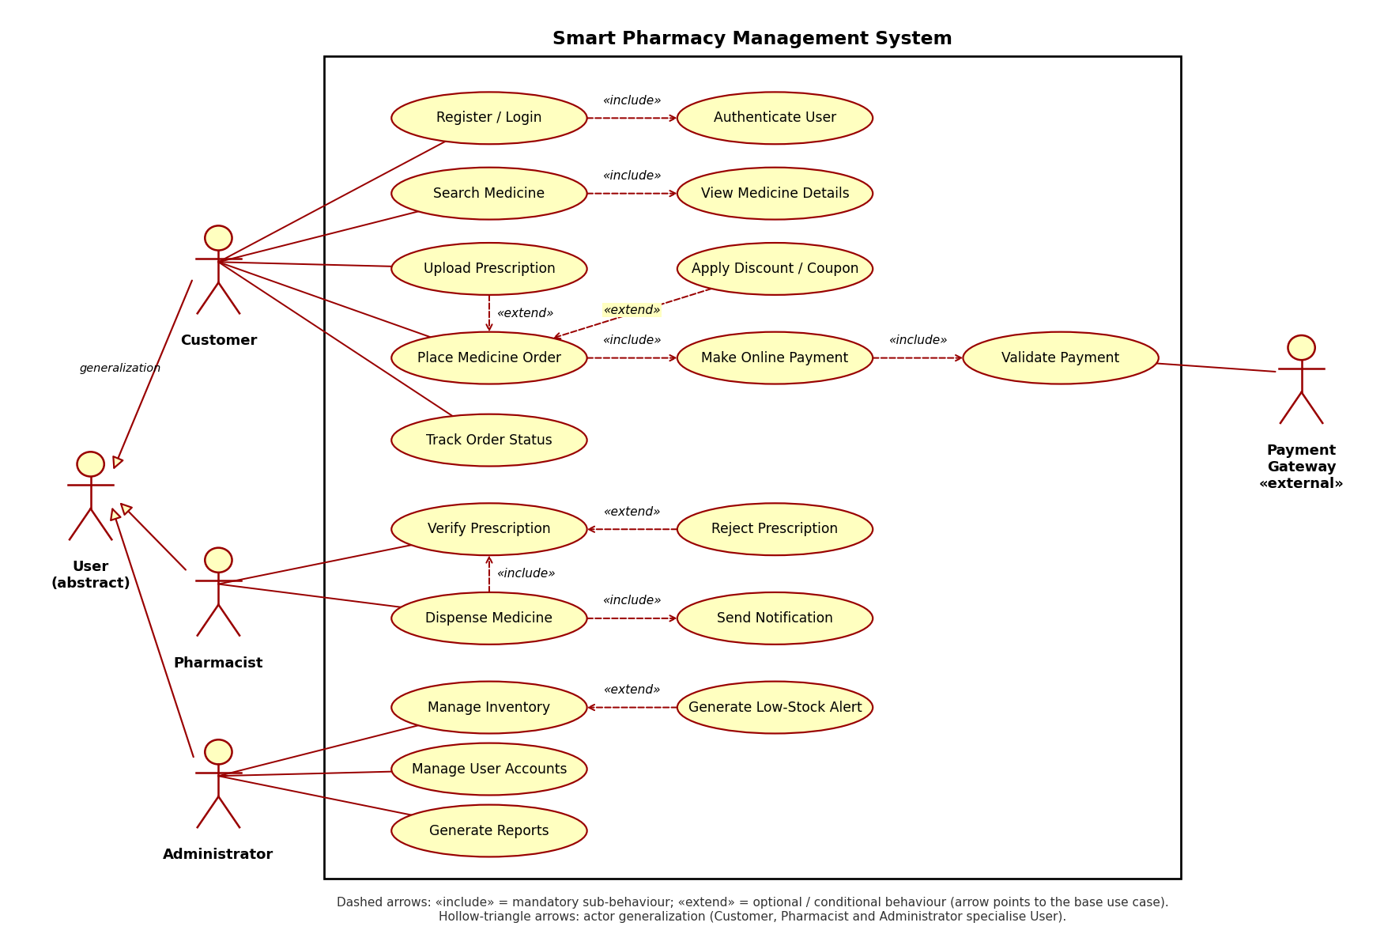
Figure 1: Use Case Diagram – Smart Pharmacy Management System
Justification
- Each actor is linked only to the use cases it is responsible for, which removes the earlier ambiguity about actor responsibilities.
- The Payment Gateway is modelled as an external secondary actor because payment validation is performed outside the system.
- Using «include» and «extend» avoids duplicated behaviour and keeps the main use cases simple and reusable.

2. Class Diagram Design (10 Marks)
Problem understanding. The Smart Library Management System contains the entities Book, Member, Librarian, Reservation, Fine and BorrowRecord, but their attributes, operations and relationships are not specified. Classes are identified from these entities, a Library class is added to represent the whole system, and Person is added as an abstract super-class to remove duplication between Member and Librarian.
Step 1 – Classes, attributes and methods
Class | Key attributes | Key operations
Person (abstract) | personId, name, email, phone, address | login(), logout(), updateProfile()
Member | memberId, membershipDate, membershipType, status | searchBook(), borrowBook(), returnBook(), reserveBook(), payFine()
Librarian | employeeId, designation, shift | addBook(), removeBook(), issueBook(), collectFine(), manageMember()
Book | isbn, title, author, publisher, category, totalCopies, availableCopies | checkAvailability(), updateCopies(), getDetails()
BorrowRecord | recordId, issueDate, dueDate, returnDate, status | calculateDueDate(), renew(), markReturned(), isOverdue()
Reservation | reservationId, reservationDate, expiryDate, status | confirm(), cancel(), expire()
Fine | fineId, amount, fineDate, paidStatus | calculateFine(), markPaid(), getBalance()
Library | name, address, maxBorrowLimit | registerMember(), addBook(), generateReport()

Step 2 – Relationships and multiplicity
Relationship | Classes | Multiplicity
Inheritance | Member → Person, Librarian → Person | Generalization (is-a)
Aggregation | Library ◇— Member, Library ◇— Book | 1 Library : 0..* Members; 1 Library : 1..* Books
Composition | BorrowRecord ◆— Fine | 1 BorrowRecord : 0..1 Fine (a Fine cannot exist without its record)
Association | Member – BorrowRecord (borrows) | 1 : 0..*
Association | Book – BorrowRecord (borrowed in) | 1 : 0..*
Association | Librarian – BorrowRecord (issues) | 1 : 0..*
Association | Member – Reservation (makes) | 1 : 0..*
Association | Book – Reservation (reserved in) | 1 : 0..*

Step 3 – Class Diagram
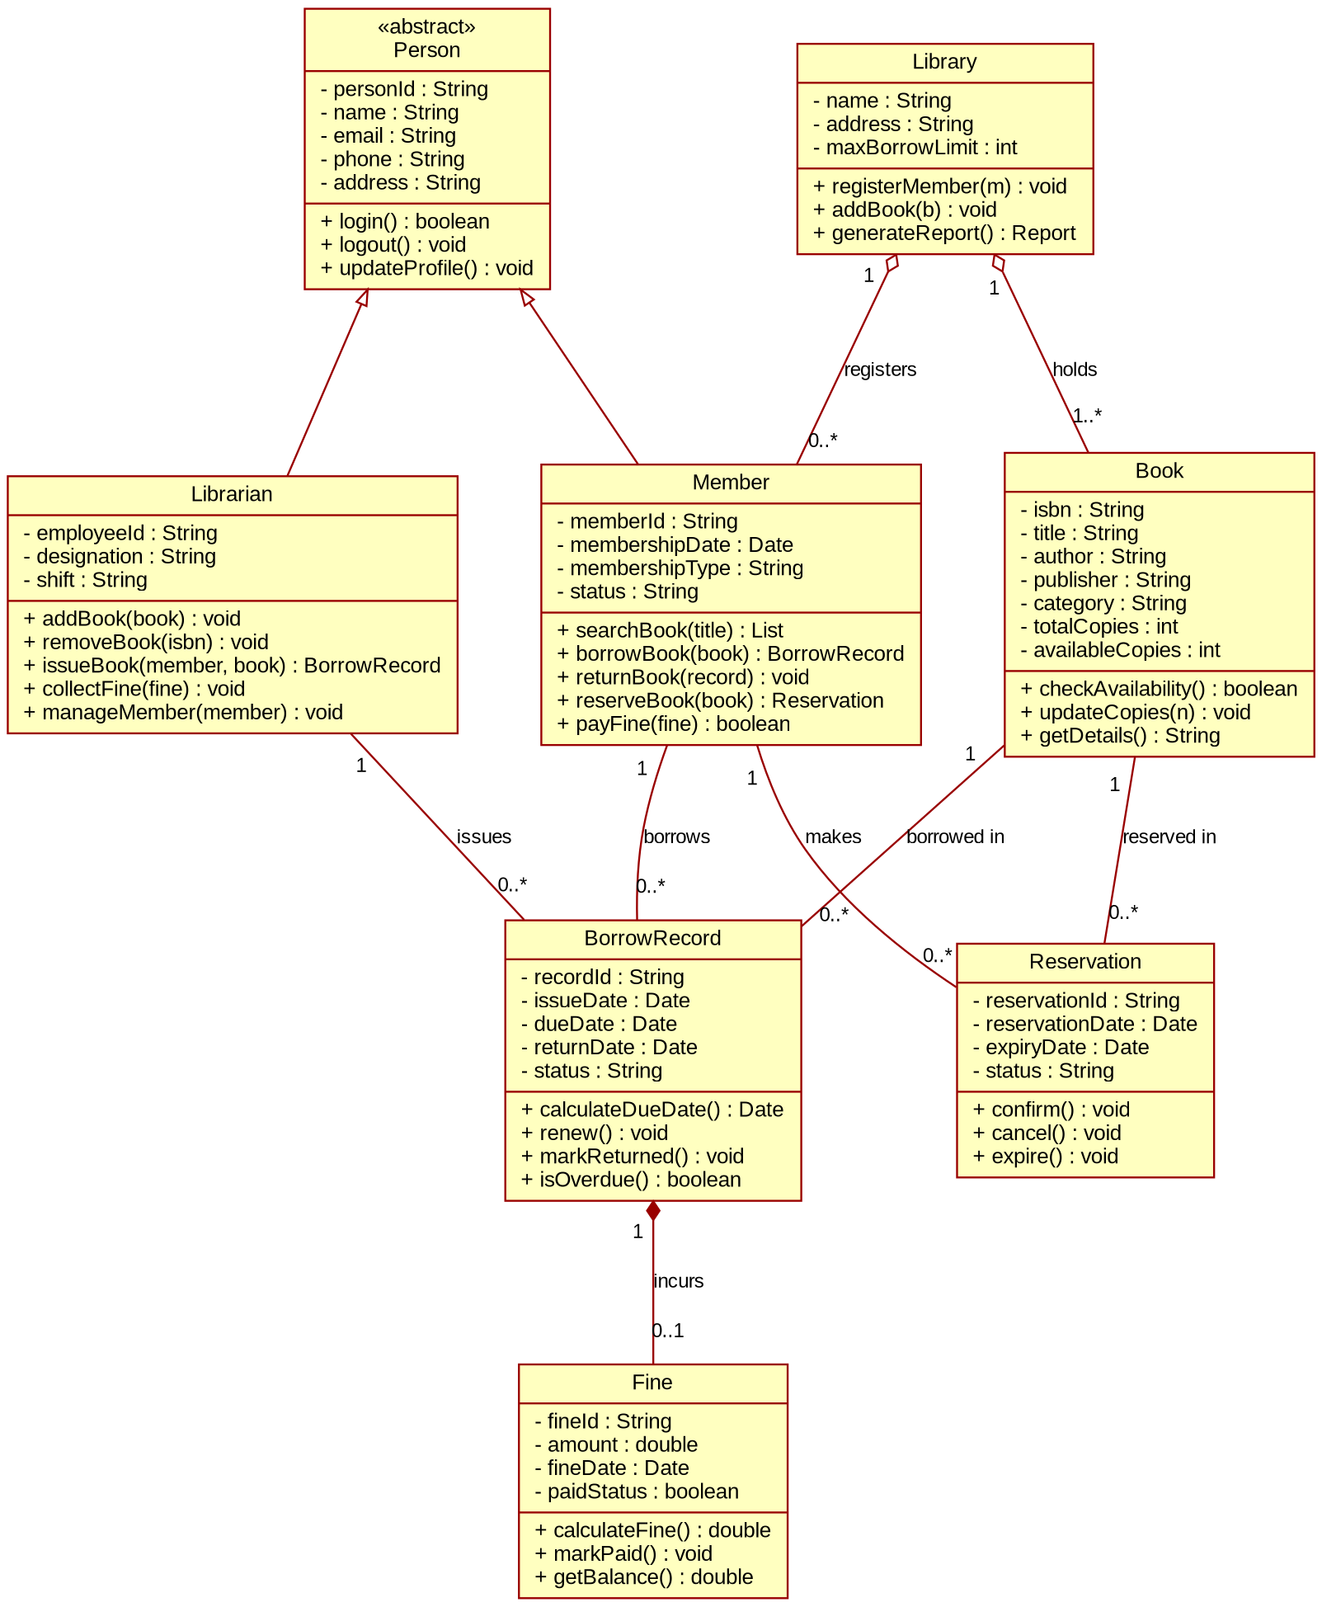
Figure 2: Class Diagram – Smart Library Management System
Justification
- Aggregation is used between Library and Member/Book because they can exist independently of the Library object; composition is used for Fine because its life cycle depends on the BorrowRecord.
- Attributes are private and operations are public, following encapsulation.
- BorrowRecord and Reservation act as association classes that resolve the many-to-many relationship between Member and Book.

3. Sequence Diagram Evaluation (10 Marks)
Problem understanding. In the Online Examination System a student logs in, selects an examination, answers the questions, submits the responses and receives the result. The communication between the student, examination module, evaluation module and database is incomplete, so every participating object and message is identified below.
Step 1 – Participating objects
Object | Role
Student (actor) | Initiates login, selects exam, answers questions and submits responses.
:LoginModule | Receives credentials and validates them against the database.
:ExamModule | Lists exams, loads questions, collects answers and shows the result.
:EvaluationModule | Evaluates submitted answers, calculates the score and stores the result.
:Database | Stores users, exams, questions, answer keys and results.

Step 2 – Missing message exchanges identified
- Credential validation between LoginModule and Database, with success / failure reply to the student.
- Fetching the list of available exams and loading the questions from the Database.
- Hand-over of answers from ExamModule to EvaluationModule, retrieval of the answer key and the self-call to calculate the score.
- Saving the result in the Database and returning the score to the student.
Step 3 – Sequence Diagram
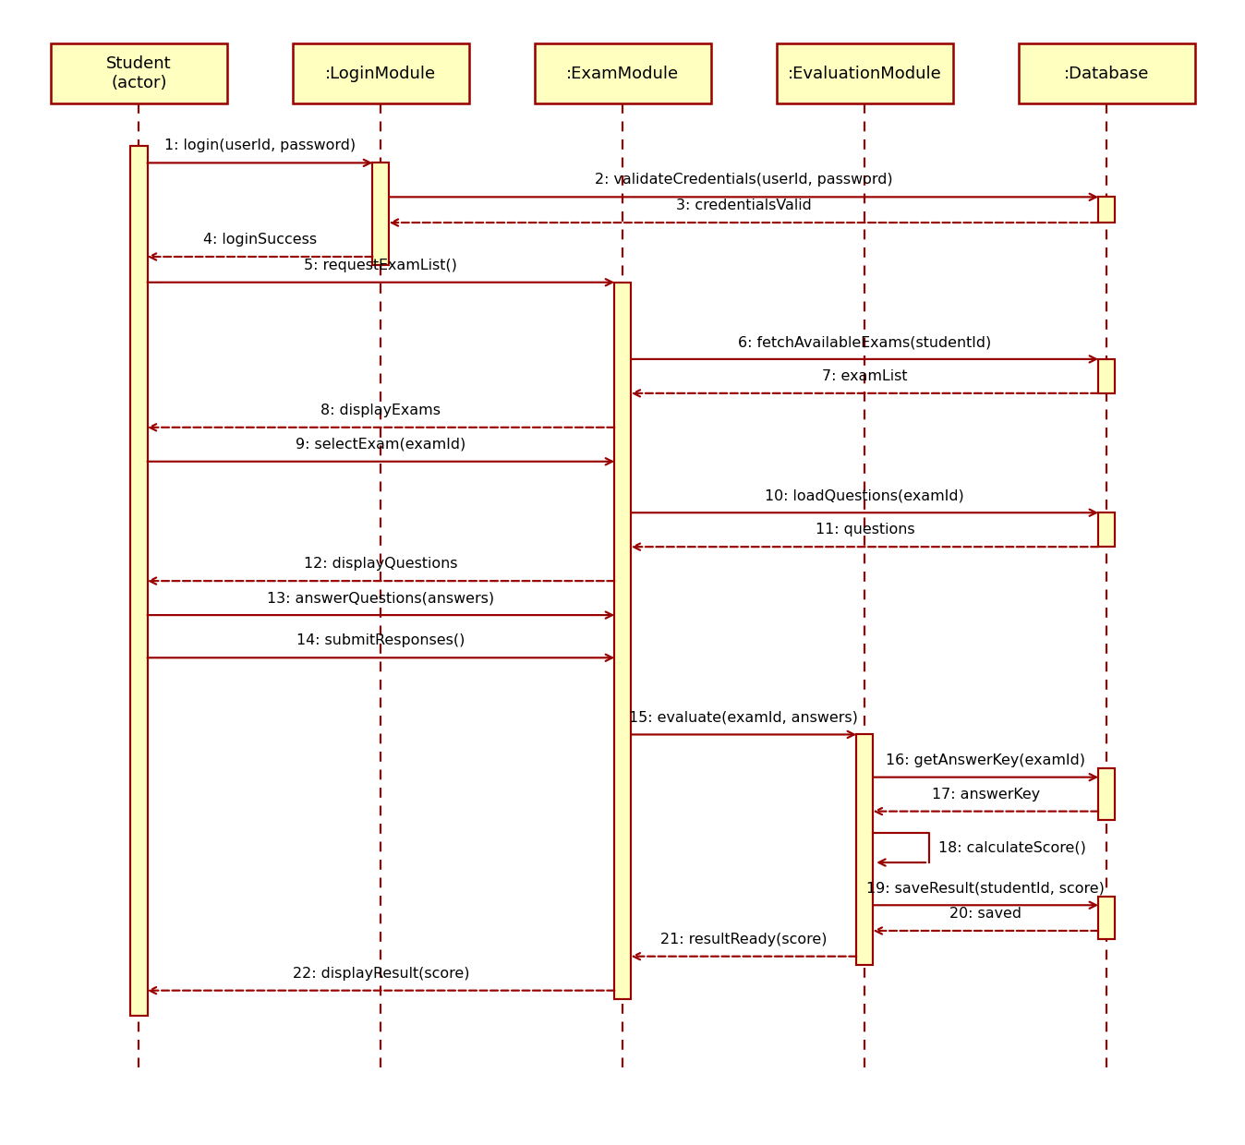
Figure 3: Sequence Diagram – Online Examination System
Justification
- Dashed vertical lines are lifelines and the narrow rectangles are activation bars showing when an object is active.
- Solid arrows are synchronous calls; dashed arrows are return messages; message 18 is a self-message for score calculation.
- The numbered messages show the complete flow: login → exam selection → answering → submission → evaluation → result.

4. Activity Diagram Construction (10 Marks)
Problem understanding. The Loan Approval System covers application submission, document upload, eligibility verification, approval or rejection and disbursement. The existing workflow lacks decision points and parallel activities, which are identified and added below.
Step 1 – Workflow activities
Stage | Activities
Application | Submit loan application; upload supporting documents; validate completeness.
Verification (parallel) | Verify identity & KYC; check credit score; verify income & employment.
Decision | Evaluate eligibility and risk score; approve or reject.
Approval path (parallel) | Send approval notification and customer signs loan agreement at the same time; then disburse loan and update records.
Rejection path | Record reason and send rejection notification.

Step 2 – Decision nodes and parallel processing
- Decision 1 – Documents complete? If No, missing documents are requested and the flow loops back to the upload step; if Yes, verification starts.
- Fork / Join 1 – identity check, credit check and income check run in parallel and are synchronised before evaluation.
- Decision 2 – Eligible? Yes leads to approval; No leads to rejection.
- Fork / Join 2 – approval notification and agreement signing run in parallel before disbursement.
Step 3 – Activity Diagram
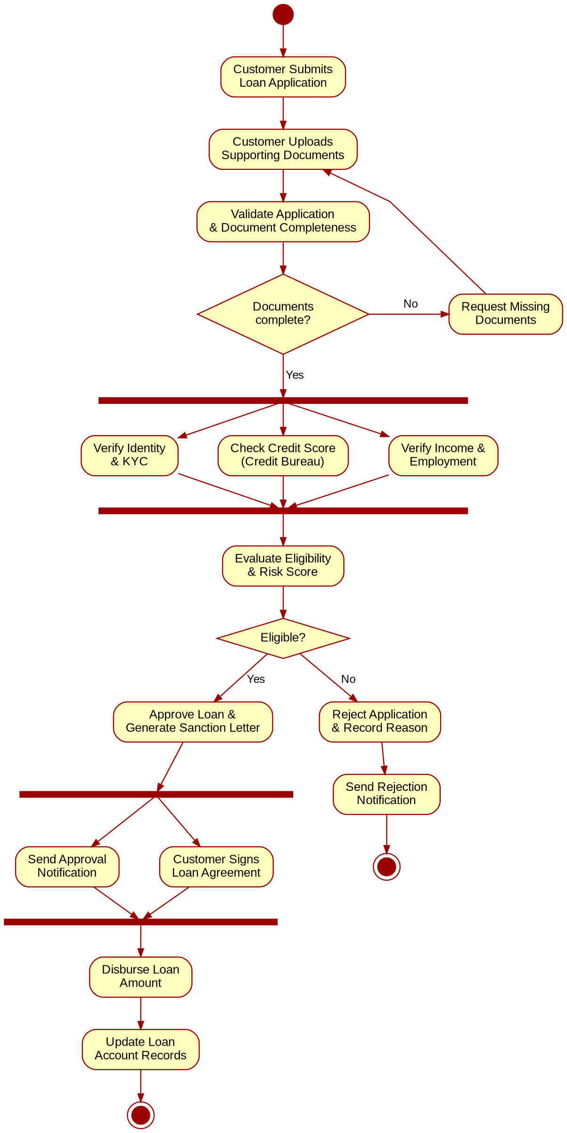
Figure 4: Activity Diagram – Loan Approval System
Justification
- Parallel verification reduces processing time compared with doing the checks one after another.
- Separate approval and rejection paths, each ending in its own final node, make the outcome of the process explicit.

5. Component Diagram Design (10 Marks)
Problem understanding. The Smart E-Commerce Platform is made of seven modules, but the interfaces they offer and the dependencies between them are not defined. Each module is modelled as a component with a provided interface, and the required interfaces are shown as dependencies.
Step 1 – Components and interfaces
Component | Provided interface | Required interfaces
User Management | IAuthentication | –
Product Catalog | ICatalog | IInventory
Shopping Cart | ICart | IAuthentication, ICatalog
Order Management | IOrder | ICart, IAuthentication, IPayment, IInventory, INotification
Payment Gateway | IPayment | INotification, IBankAPI (external bank)
Inventory Management | IInventory | –
Notification Service | INotification | –

Step 2 – Component Diagram
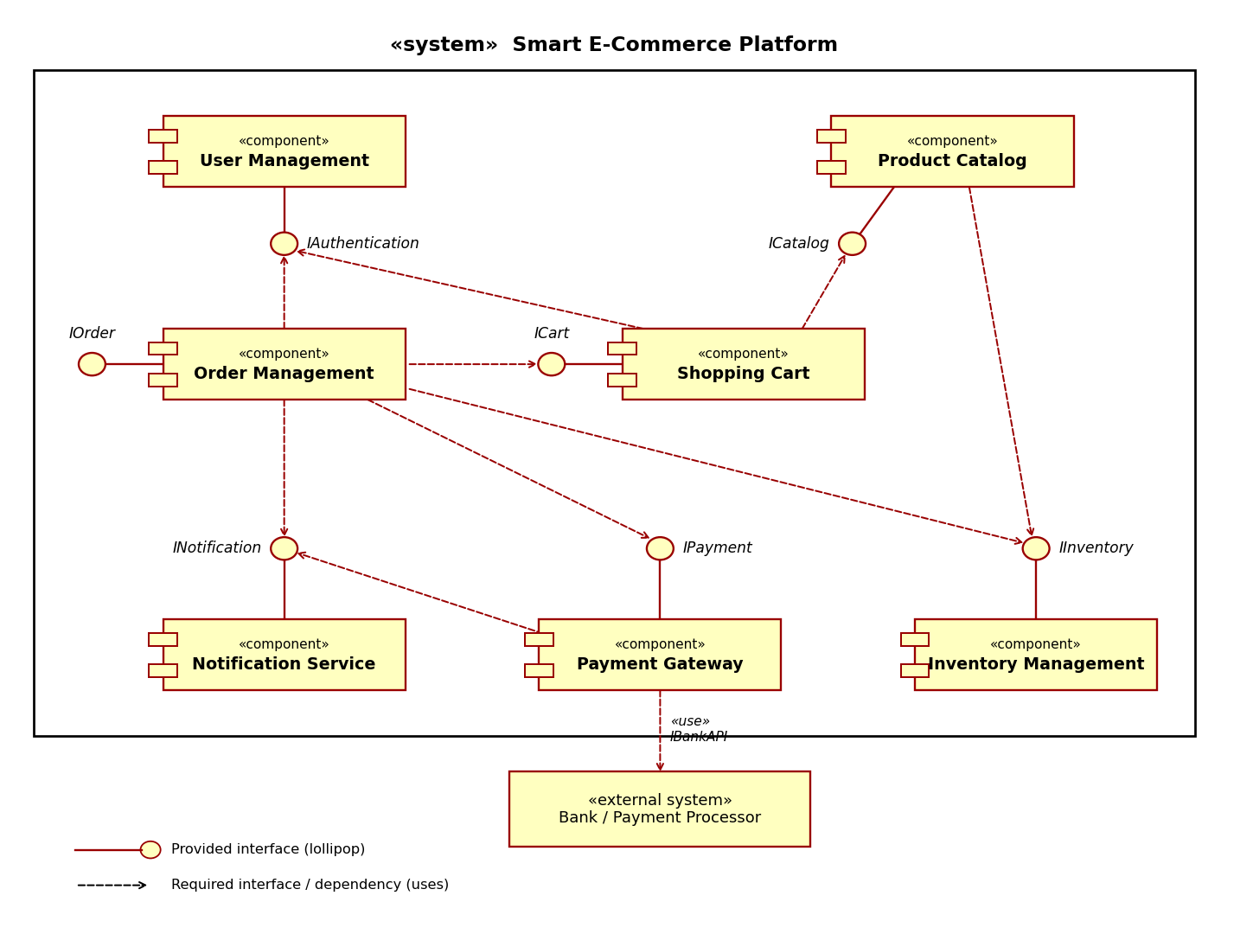
Figure 5: Component Diagram – Smart E-Commerce Platform
Justification
- Lollipop symbols are provided interfaces; dashed arrows to a lollipop are required interfaces (dependencies).
- Order Management is the central component that coordinates cart, payment, inventory and notifications.
- Components depend on interfaces rather than on each other directly, so a module such as Payment Gateway can be replaced without changing the others.

6. Deployment Diagram Design (10 Marks)
Problem understanding. The Smart Agriculture Monitoring System uses IoT soil sensors, weather stations, irrigation controllers, cloud servers, a mobile application and a farmer dashboard to monitor crops and automate irrigation. The hardware nodes, the software artifacts deployed on them and the communication links are identified below.
Step 1 – Nodes and artifacts
Node | Artifacts deployed | Purpose
IoT Soil Sensor Node | soil_sensor_fw.bin | Measures soil moisture, pH and temperature.
Weather Station | weather_agent.bin | Measures rain, wind, humidity and temperature.
Edge Gateway | gateway_service.jar, mqtt_client.conf | Collects field data and forwards it to the cloud; relays control commands.
Irrigation Controller | irrigation_ctrl.bin | Operates solenoid valves and pump relay.
Cloud Application Server | monitoring_service.war, irrigation_engine.jar, rest_api.war | Analyses data, decides irrigation, exposes REST API.
Database Server | sensor_data.db | Stores sensor readings and crop records.
Farmer's Smartphone | farmer_app.apk | Mobile monitoring and control.
Farmer's PC / Browser | farmer_dashboard.html | Web dashboard.

Step 2 – Communication links
Link | Protocol
Soil Sensor ↔ Edge Gateway | LoRa / Zigbee (868 MHz)
Weather Station ↔ Edge Gateway | LoRa / RS-485 (Modbus)
Edge Gateway ↔ Irrigation Controller | LoRa / RS-485 (control commands)
Edge Gateway ↔ Cloud Application Server | MQTT over TLS (4G / Wi-Fi)
Cloud Application Server ↔ Database Server | JDBC / SQL (TCP 3306)
Smartphone / Browser ↔ Cloud Application Server | HTTPS / REST, WebSocket

Step 3 – Deployment Diagram
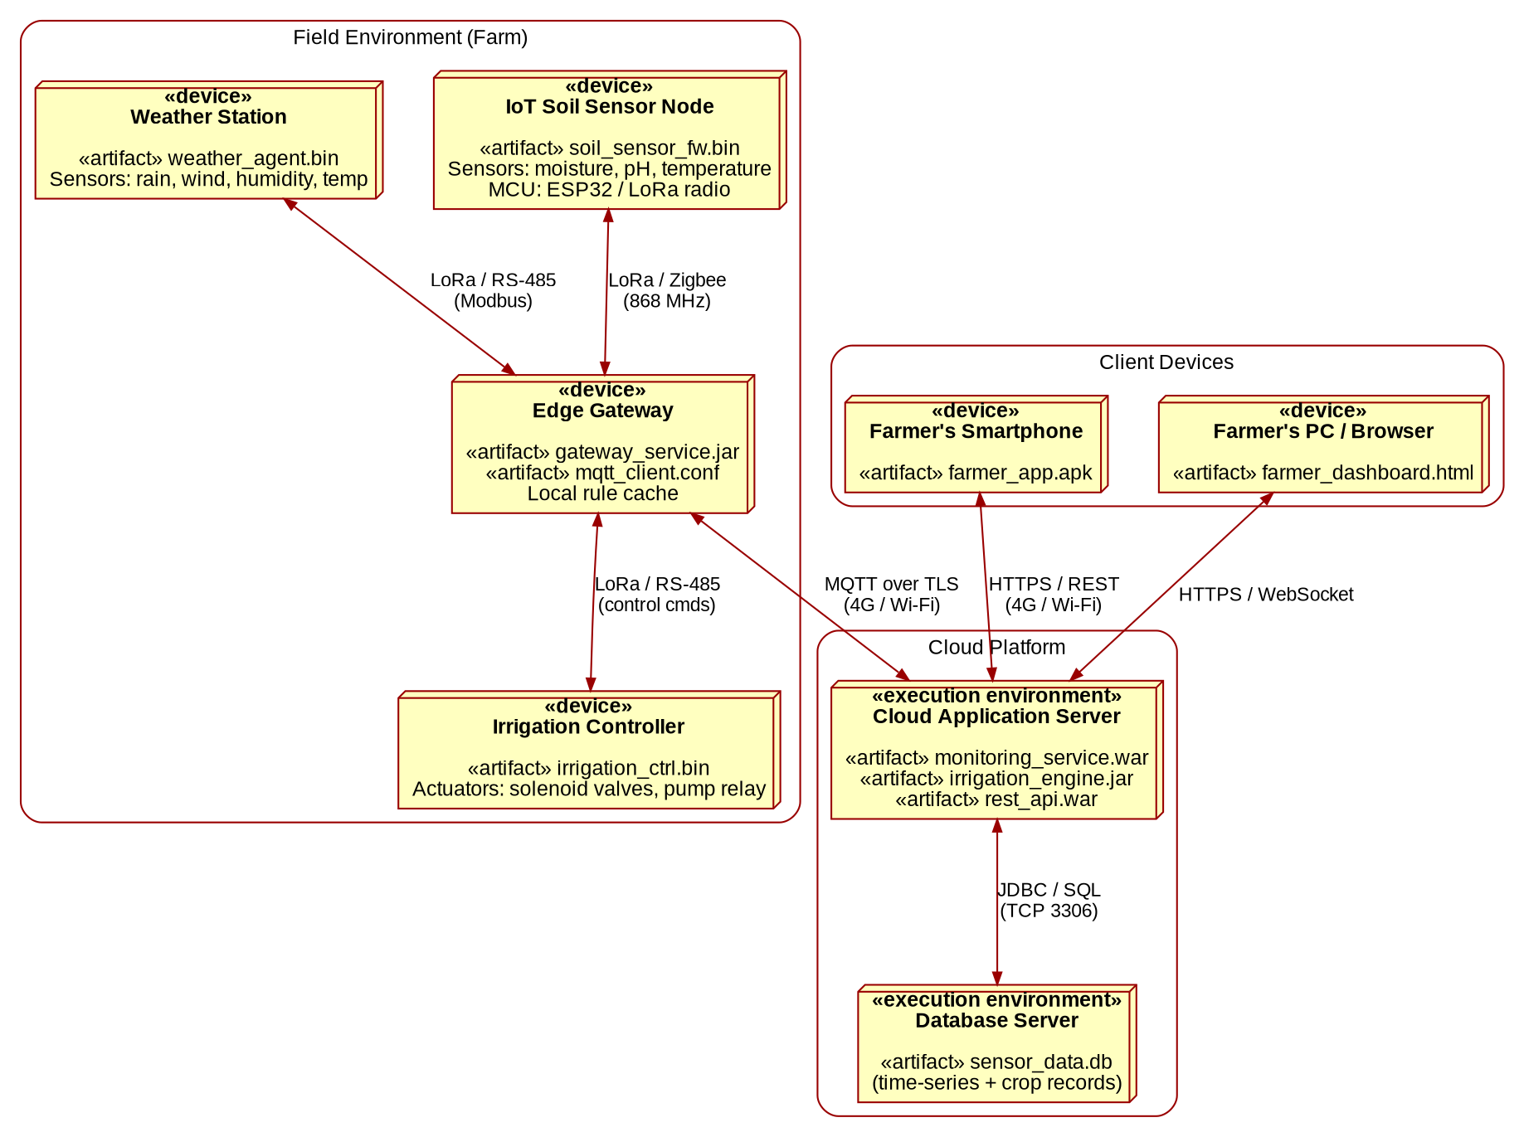
Figure 6: Deployment Diagram – Smart Agriculture Monitoring System
Justification
- Low-power protocols (LoRa/Zigbee) are used in the field, while secure MQTT/HTTPS is used over the internet.
- The edge gateway reduces cloud traffic and allows the controller to receive commands even through a single link.
- Separating the application server and database server improves scalability and security.

